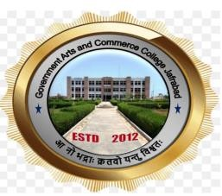

GOVERNMENT ARTS AND COMMERCE COLLEGE, JAFRABAD

Visit to Gram Vidypith, Sanosara

REPORT OF Visit HELD ON 11th March, 2024

COMMITTEE SSIP

Co-ordinator Principal
Prof Yamuna Panicker Dr. Viralkumar Shilu

Objective of the Visit
The Student Startup and Innovation Committee of the college took the students to Gram Vidyapith, Sanosara. Following were the major Objectives of the Visit.
- To motivate our students towards agriculture-based startups
- To get guidance for our students interested in the Moring Health Project
- To make them aware about the student innovations at Lokbharti institute and derive motivation from the same

About the Gram Vidyapith, Sanosara

Lokbharti University focuses exclusively on rural innovation. It was accorded with Private University Status, Under Gujarat Private University Act, 2022. The aim of the institute is to impart higher education based on Gandhian Principles. The institute strives to educate the rural community and foster innovation for sustainable rural development. The university also houses the Krishi Vikas Kendra. The KVK of the university works in close contact with the rural community, imparting the knowledge of machinery and innovative technologies with them.

About the Visit

Eleven students of the college were taken to the visit at GramVidyapith Sanosara. A bus was hired for the travel. Faculty and the students reached the venue at 11.00 am.

Students got a chance to view and understand the basic machinery of food processing

The students involved with the moringa project, shared the problems faced by them in developing the product and got inputs from the experts.

Students were inspired by witnessing the innovative tools made by the students of Lokbharti Institute

Students visited the Gaushala and milk processing plant where value added products like ice creams were made.

Students had one to one interaction with the chief scientist and the home science faculty

The vice-chancellor of the institute also interacted with our students

List of students Participants
